Exploring Innovative STEM Education
Through Guitar Design and Manufacture

Funded Through the National Science Foundation
NSF DUE ATE Grant 0903336

Hosted by Ventura College, Ventura, CA
Presented by: Steve Brown-College of the Redwoods- CA, Scot Rabe-Ventura College-CA, Mark French-Purdue University- IN, Doug Hunt-Southern Wells High School-IN, Mike Aikens Butler County Community College-PA, Tom Singer-Sinclair Community College-OH, Debbie French-New Philadelphia High School-OH,



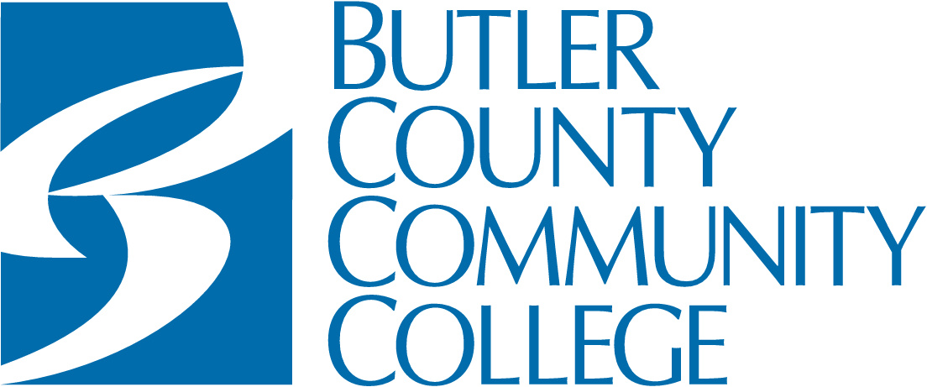
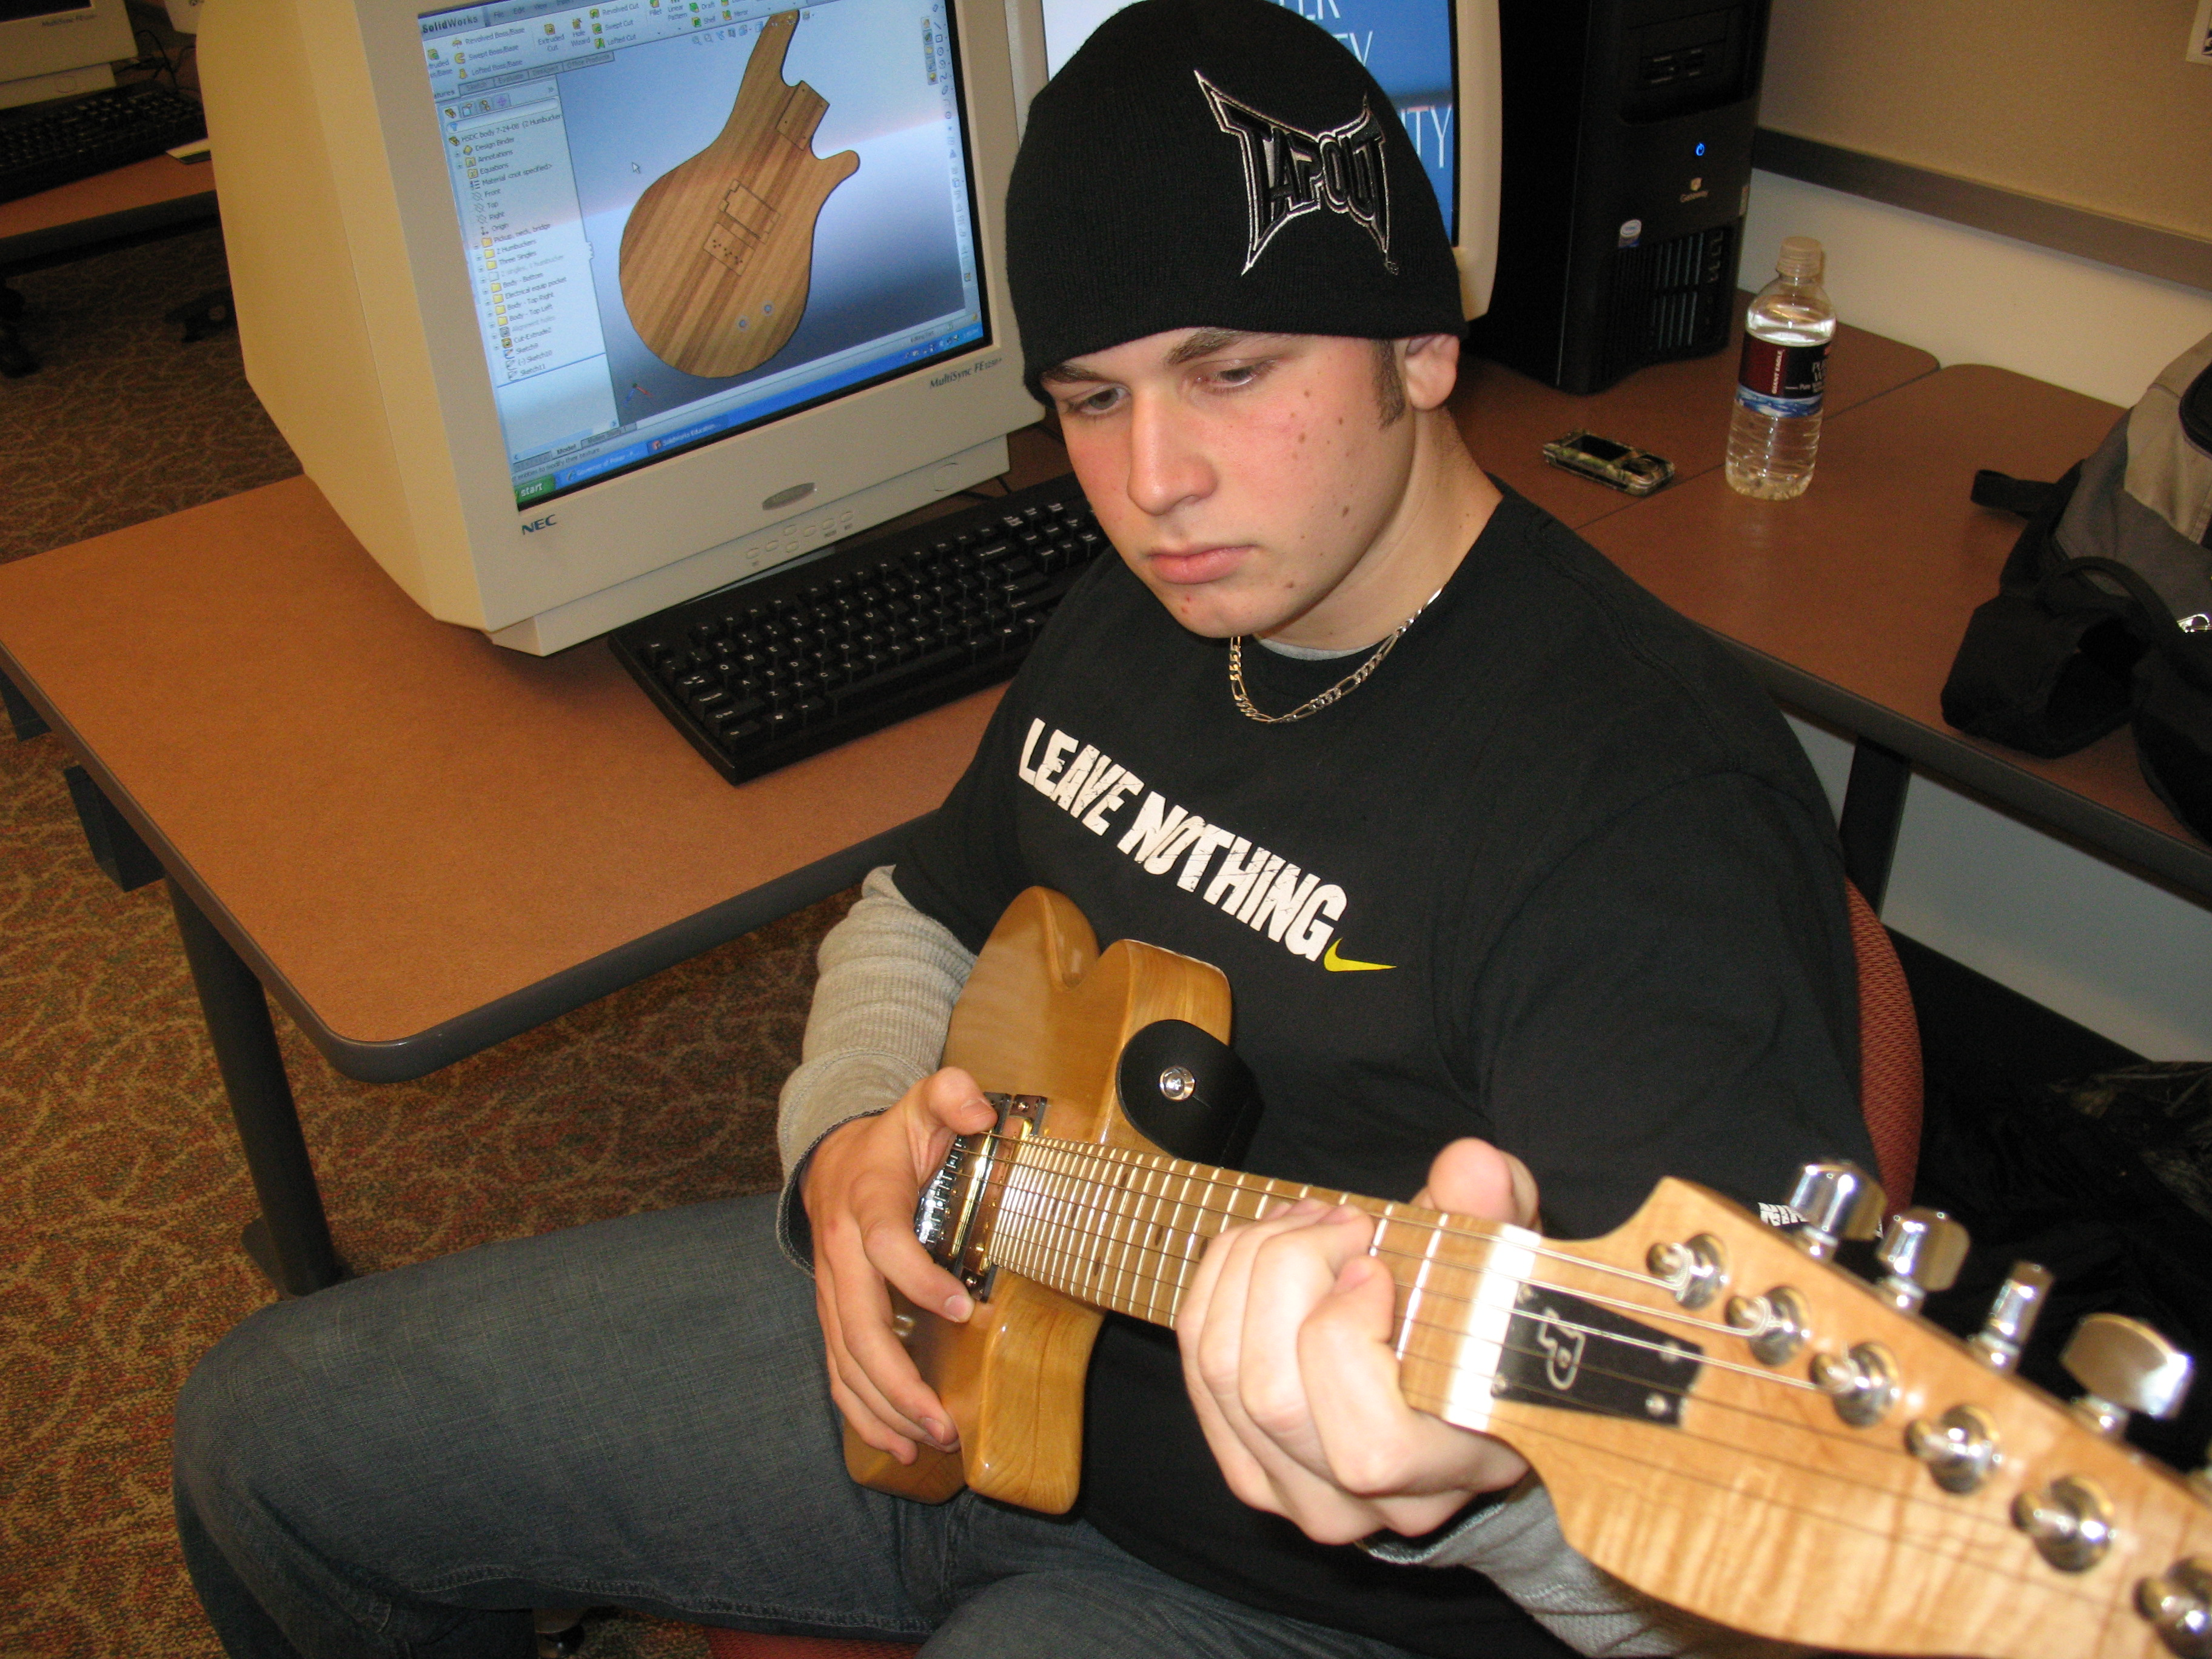





At the completion of this faculty development workshop, participants will have experienced an innovative project based STEM curricula including hands-on experiential learning and cutting edge technology for the day-to-day classroom experience. The solid body electric guitar project will be introduced as an innovative vehicle for teaching concepts in Science, Technology, Engineering and Mathematics.

Monday- June 25, 2012

AM SESSION

8:30 – 9:00 Welcome
- Introductions and Workshop Overview
- Administrative Paperwork
  - W-9 Incentive Payee Form, Attendance Form, Photo Release Form, etc.

9:00 – 9:45 Guitar Primer

9:45 – 10:00 Overview of Workbook and Learning Activities

10:00 – 10:15 Break

10:15 – 10:45 Guitar Headstock Design for CNC Router Demonstration

10:45 – 12:00 Lab for Headstock Design, 3D Virtual Modeling and/or Cost Analysis

12:00 – 1:00 Lunch - Provided

PM SESSION

1:00 – 1:30 Shop Orientation, Safety and Component Selection

1:30 – 3:45 Task 1 – Body Sculpting (optional) – Power planer, rasps & bladder sander
NO FLY ZONE ALERT

Task 2 – Neck - separate from blank, file/sand neck & headstock
NO FLY ZONE ALERT

Task 3 – Drill pickup access hole and Jack hole

Task 4 - Glue fret board onto neck

4:00 – 4:30 Seal body with Bona Seal

5:00 – 5:30 First application of clear Bona Mega

Homework: register and record a skype account (SKYPE.COM) to be used in Wednesday’s lab.

Tuesday- June 26, 2012

AM SESSION

8:00- 10:00 Science activities – Debbie French

10:00 - 10:15 Break

10:15 – 11:15 Technology & Math activities Doug Hunt

11:15 – 12:00 Lab for STEM Activities

12:00 – 1:00 Lunch - Provided

PM SESSION

1:00-1:15 Second coat of finish on guitar bodies

1:15-1:45 Drill and install fret dots. (wood and plastic available)

1:45-3:00 Sand 12” radius on fret board, shape/sand neck and headstock. Apply sealer
3:00-3:15 Fretting demonstration

3:15 – 4:45 Fretting (seal fret board and neck before fretting)

4:45 – 5:15 Swirl Paint Demonstration

5:15- 5:30 Apply third coat of finish on body and first coat on neck

Wednesday- June 27, 2012

AM SESSION

8:00-8:30 Apply last coat of finish to body and neck

8:30-10:00 Tom Huber – Physics/Science

10:00-10:15 Break

10:15 – 12:00 Introduction to On-Line Collaborative Design Tools
- Skype (VOIP), check headset and mic connection
- Adobe Connect
- Autodesk Streamline / Buzzsaw

Remote Design Team Exercise using Solid Body Electric Guitar Neck and/or Hollow Body Acoustic Electric Guitar Neck files found on instructor resource DVD.
- Log on to Adobe Connect
- Design project will be discussed using virtual classroom (Adobe Connect)
- Remote design teams work on a new head stock design.
- Post results on Streamline
- In the CADD system, cut new headstock off of neck and save as an STL file. This file will be used to create a scaled physical model (prototype) of the new design.
- Print designs if so desired.

12:00 – 1:00 Lunch - Provided

PM SESSION

1:00 – 2:00 Complete Fretting and Install side markers.

2:00-2:15 Fret Leveling demonstration

2:15- 5:30 Fret Leveling and Install Hardware on body

Thursday- June 28, 2012

AM SESSION

8:00 – 9:00 Curriculum integration discussion

9:00 – 10:00 Networking and Learning Activity Development

10:00-10:15 Break

10:15 – 10:45 Participant-centered discussion of newly developed learning activities

10:45 – 12:00 Introduction to soldering and electronics wiring harness

12:00-1:00 Lunch - Provided

PM SESSION

1:00-1:30 Nut making and installation demonstration

1:30 – 3:00 Solder wiring harness and install electronics

3:00 – 4:00 Neck and string installation demonstration

4:00 – 5:30 Attach Neck and string guitar

Friday- June 29, 2012

AM SESSION

8:00 – 8:30 Breakfast

8:30 – 9:00 Distribute Materials to Support Activities

9:00 – 10:00 Intonation and tuning demonstration

10:00-10:15 Break

10:15 – 12:00 Set-up, intonation and tuning

12:00 – 1:00 Lunch - Provided

PM SESSION

1:00 – 1:30 Evaluation

1:30-2:00 Group Picture

2:00 - ? Finish guitar set-up

