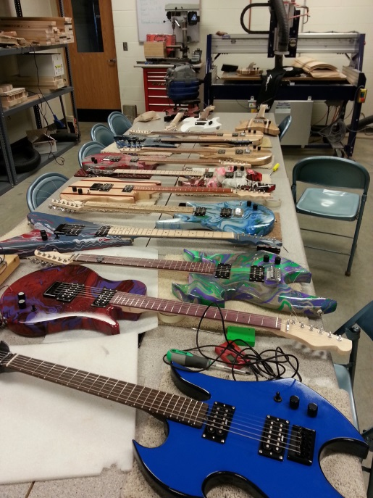**Required Pre-attendance Webinar / video for participants include a guitar terminology primer and worksheet / short cycle assessment.**

**Sample 5 day Institute schedule**

## **Sunday**

### 12pm – 4:00pm **Room setup Training team only**

### Equipment and tool inventory

### Table layout

### Dust collection – floor covering

### Materials sorted

### Kits assembly

### Purchase list of items

* Prepare finish area

Stebbins HS in Dayton, OH class guitars

## **Monday**

### **AM SESSION**

### Arrival at event 8:15 am

### 8:15 – 9:15 Welcome

### Introductions and Workshop Overview

### Administrative Paperwork

### Attendance Form, Photo Release Form, etc.

### 

### Expectations / goals for the week & year, review of Cost Analysis of Guitar Homework and short cycle assessments, Mapping national or state standards to curriculum, Outline of curriculum development project for the week (Thursday faculty discussion)

Project Staff support - Who, What, Where

### 9:15 -10:15 Selection of Bodies and necks

10:15-10:30 Break

10:30 – 11:30 Guitar Headstock Design –sketching. *Additional activity development ideas: surface area, geometry of design, angles & trigonometry, measurement* Lab time for Headstock Design.

11:30 – 12:00 Short Cycle assessment on Cost Analysis of Guitar activates using quia

12:00 – 1:00 Lunch

#### PM SESSION

Goal: Body sculpted, neck and fretboard Glued (back of neck scraped)

1:00 – 1:30 Shop Orientation, Safety and Component Selection

1:30 – 4:30 Task 1 – Body Sculpting (optional) – Power planer, rasps & bladder sander

**NO FLY ZONE ALERT**

Task 2 – Neck - separate from blank, file/sand neck & headstock

**NO FLY ZONE ALERT**

Task 3 – Drill pickup access hole and Jack hole

Task 4 - Glue fret board onto neck

4:30- 5:00 Seal body with Bona Seal

5:00 – 5:30 First application of clear Bona Mega water based polyurethane

**HOMEWORK: Review Videos on Neck finishing and fretting + initial thinking on learning activity**

## **Tuesday**

### **AM SESSION**

### 7:45 - 8:15 Light sand + coat of finish on body - Prior to class

### 8:15 - 9:15 Technology & Math activities – hands on activities for classroom, adaptive for many levels of instruction – fretboard activity short cycle assessment MAY not finish whole activity

9:15 – 10:15 How we have implemented; plus how others have implemented – Class Roadmap - 16 weeks;

Evaluation Roadmap, Next Gen standards and Common core standards

10:15- 10:30 Break

10:30 – 12:00 Take existing activities and map them to common core and Next gen - Swirl Dipping mini guitars

12:00 – 1:00 Lunch

#### PM SESSION

Goal: Fret Board Radiused and finish coats (multiple on Body / Neck)

1:00-1:15 Coat of finish on guitar bodies

1:15-2:30p Team 1: Drill and install fret dots. (wood available)

1:15-2:30p Team 2: Sand 12” radius on fret board, shape/sand neck and headstock. Apply sealer to fretboard

2:30-2:45 Break

2:45 -3:30 Teams 1 and 2 Switch activities

3:30 Fretting demonstration - Swirl Paint Demonstration

4:00 – 5:15 Fretting (seal fret board and neck before fretting) & swirl paint bodies

5:15- 5:30 Apply third coat of finish on body and first coat on neck

**HOMEWORK: Review the Soldering video + learning activity development / planning**

## **Wednesday**

### **AM SESSION**

8:00-8:30 Apply last coat of finish to body and neck (optional)

### 8:30-10:00 Evaluation: Quia How to use in your classroom: Logins with Faculty ID’s, student Id’s, General time line of evaluations (evaluation timeline), Becoming a case study classroom (Sinclair only)

10:00-10:15 Break

10:15 – 12:00 Technology activity - truss rods as beams and / or wood materials activities - hands on activities for classroom with short cycle assessment

12:00 – 1:00 Lunch-- soldering Video

Introduction to soldering and electronics wiring harness

#### PM SESSION

Goal : Fretting and wiring harness – Maybe a sound check?

1:00 Soldering Demonstration

1:30 – 2:00 Complete Fretting and Install side markers

3:30 Fret Leveling demonstration

4:00- 5:30 Fret Leveling and Install Hardware on body

**HOMEWORK : Review Video on Hardware installation + Finalize learning activity outline and details for Thursday sharing session**

## **Thursday**

### **AM SESSION**

8:00 – 9:30 Fasteners Activity & Short Cycle Assessment - Lab for STEM Activities

9:30 – 10:00 On-line resources available for your classroom

10:00-10:15 Break

10:15 – 11:30 Participant-centered discussion of newly developed learning activities

11:30 – 12:00 Manufacturing skills gaps (SME, Boeing)

12:00 -1:00 Lunch

**HOMEWORK : Check out how it’s made, made in America and Fender, PRS, Taylor , Ibanez Websites for factory tour videos.**

#### PM SESSION

Goal – Guitar Shaped objects! No one leaves until necks are attached on ALL guitars – We work as a team!

1:00-1:30 Hardware installation demonstration

1:30 – 3:00 Solder wiring harness and install electronics

3:00 – 4:00 Neck and string installation demonstration

4:00 – 5:30 Attach Neck and string guitar – GSO

## **Friday- - ROCK STAR FRIDAY**

#### AM SESSION

### 8:00 – 9:30 Intonation and tuning presentation with short cycle assessment

### 9:30 – 10:45 Set-up, intonation and tuning Lab time

### 10:45 – 11:30 Reflective Evaluation, remaining short cycle assessments, paperwork

11:30 – 12:30 Lunch

#### PM SESSION

1:00 – 4:00 Intonation of guitars continued

1:30 - 2:00 Group Picture - Jam

4pm – 5pm Tool re-pack and cleanup