**CAD/CAM, Product Design and Measurement Technologies Laser Cut Drilling Jigs**

Computer-aided design (CAD) is the use of [computer](http://en.wikipedia.org/wiki/Computer) systems to assist in the creation, modification, analysis, or optimization of a [design](http://en.wikipedia.org/wiki/Design). CAD software is used to increase the productivity of the designer, improve the quality of design, improve communications through documentation, and to create a database for manufacturing. CAD output is often in the [form of electronic files](http://en.wikipedia.org/wiki/List_of_file_formats#Computer-aided) for 3D printing, CNC machining, or other manufacturing operations.

CAD software for mechanical design uses either vector-based graphics (X/Y/Z data) to depict the objects of traditional drafting, or may also produce [raster graphics](http://en.wikipedia.org/wiki/Raster_graphics) (Pictures and images) showing the overall appearance of designed objects. As in the manual [drafting](http://en.wiktionary.org/wiki/drafting) of [technical](http://en.wikipedia.org/wiki/Technical_drawing)  [drawings](http://en.wikipedia.org/wiki/Engineering_drawing), the output of CAD must convey information, such as materials, processes, [dimensions](http://en.wikipedia.org/wiki/Dimension), and [tolerances](http://en.wikipedia.org/wiki/Engineering_tolerance), according to application-specific standards (see, ASME Y14.5).

CAD is an important industrial tool widely used in many industries, including commercial products, automotive, boat building, and aerospace industries, mechanical/industrial and architectural design, Biotech, and many more. CAD is also widely used to produce [computer animation](http://en.wikipedia.org/wiki/Computer_animation) for [special effects](http://en.wikipedia.org/wiki/Special_effect) in movies, [advertising](http://en.wikipedia.org/wiki/Advertising) and technical manuals, often called DCC [Digital content creation](http://en.wikipedia.org/wiki/Digital_content_creation).

Computer-aided manufacturing (CAM) is the use of computer software to control [machine tools](http://en.wikipedia.org/wiki/Machine_tool) and related machinery in the [manufacturing](http://en.wikipedia.org/wiki/Manufacturing) of work pieces. CAM may also refer to the use of a computer to assist in all operations of a manufacturing plant, including planning, management, transportation and inventory control. Its primary purpose is to create a faster production process and to produce components and tooling with more precise dimensions and consistency. CAM is a computer-aided process using information created during design and testing of a [computer-aided design](http://en.wikipedia.org/wiki/Computer-aided_design) (CAD) model. The model generated in CAD can be uploaded into CAM software, which then produces codes to control the machine tool.

Traditionally, CAM has been considered as a [numerical control](http://en.wikipedia.org/wiki/Numerical_control) (CNC) programming tool, where in two-dimensional (2-D) or three-dimensional (3-D) models of components generated in [CAD](http://en.wikipedia.org/wiki/Computer_aided_design) software are used to generate [G-code](http://en.wikipedia.org/wiki/G-code) or [M-code](http://en.wikipedia.org/wiki/M-code) etc., which may be company/controller specific, to drive computer numerically controlled ([CNC](http://en.wikipedia.org/wiki/CNC)) machines.

As with other “Computer-Aided” technologies, CAM does not eliminate the need for skilled professionals such as [manufacturing engineers](http://en.wikipedia.org/wiki/Manufacturing_engineer), NC programmers, or [machinists](http://en.wikipedia.org/wiki/Machinist). CAM, in fact, leverages both the value of the most skilled manufacturing professionals through advanced productivity tools, while building the skills of new professionals through visualization, simulation and optimization tools.

In this lesson, you will learn to identify part features, dimensions and tolerances on a CAD drawing, develop an acceptable plan of manufacturing process and tooling expected of a feature, and specify speed and feed calculations for the features using industry standards.

**Learning Objectives**

Situation: Given that our Shopbot CNC Router is not capable of automatic tool changes (non-ATC) we must route the guitar body using only one router bit; a 5/16” end-mill. This requires one to go back and drill the needed neck, string and pilot holes after the CNC router has finished its programmed profile and pocket tool paths. Thus, the goal is for one to make drilling jigs that can be accurately and easily placed to locate the various holes that the CNC router wasn’t able to machine.

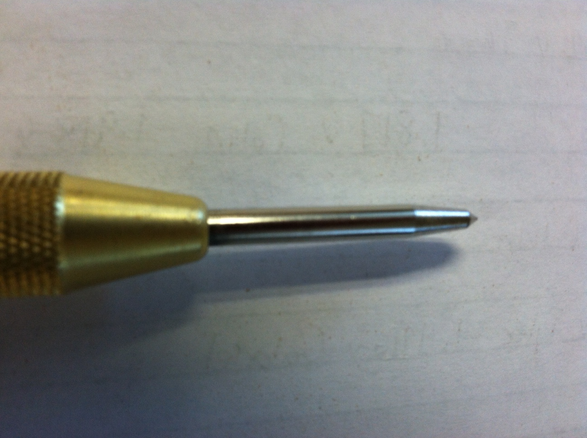

To mark the locations, one uses the jig and a spring loaded centering punch to create the drilling dimples.

1. Students will determine the measurements needed for the size and location of the string holes, mounting holes and rear pickup ring screw holes from an existing guitar body and drawings.

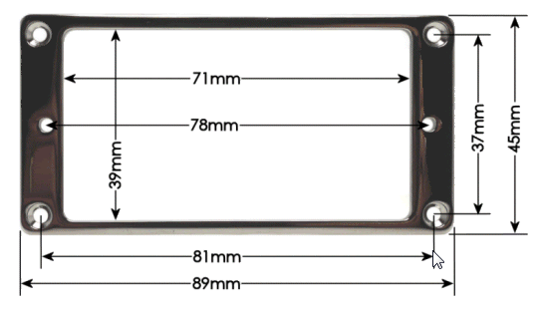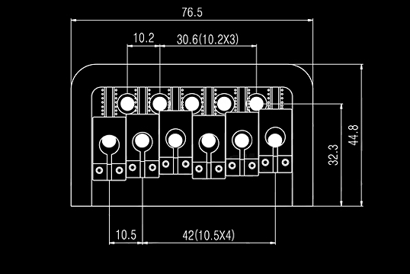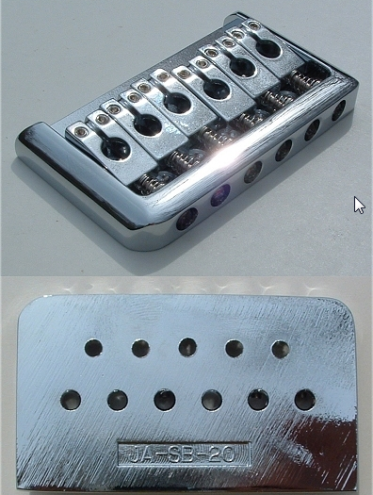

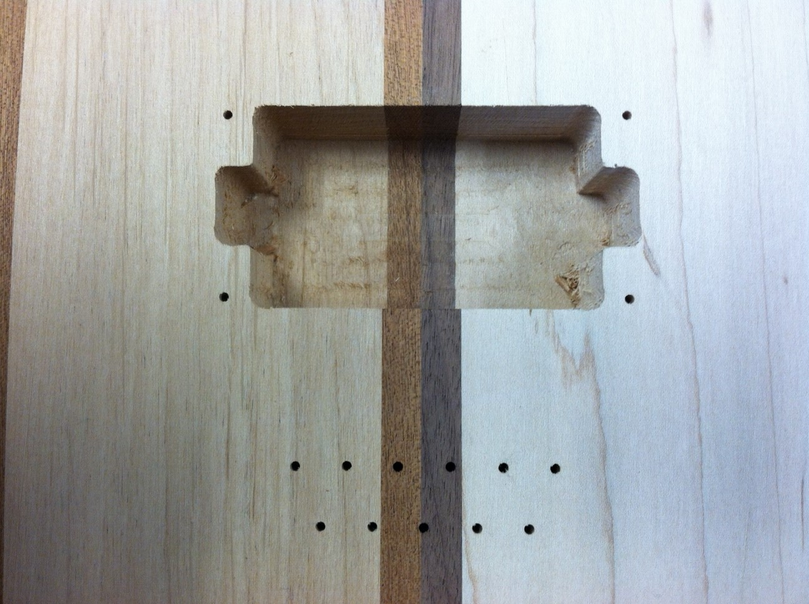

1. Students will review a drawing of a guitar’ bridge or similar object with the intent of manufacturing a jig that can be used to locate the precise placement of the needed hole locations.

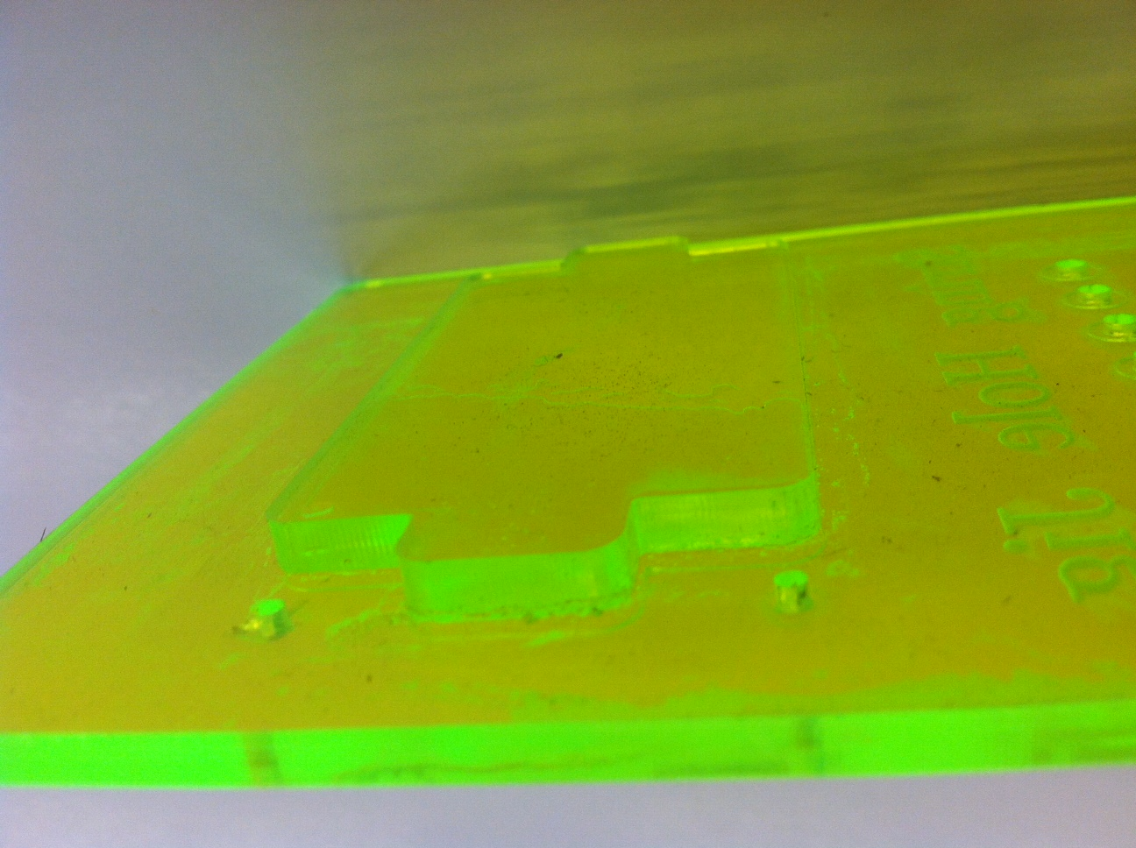

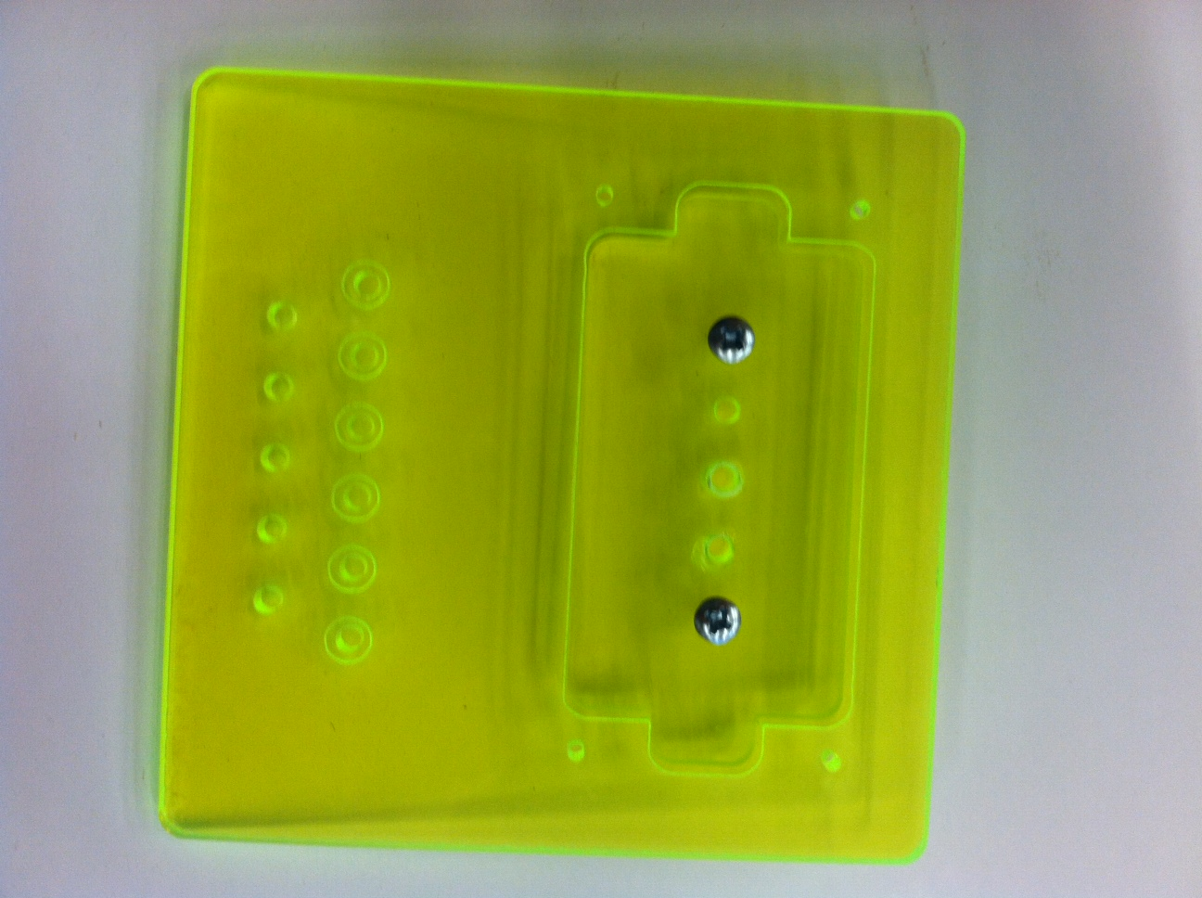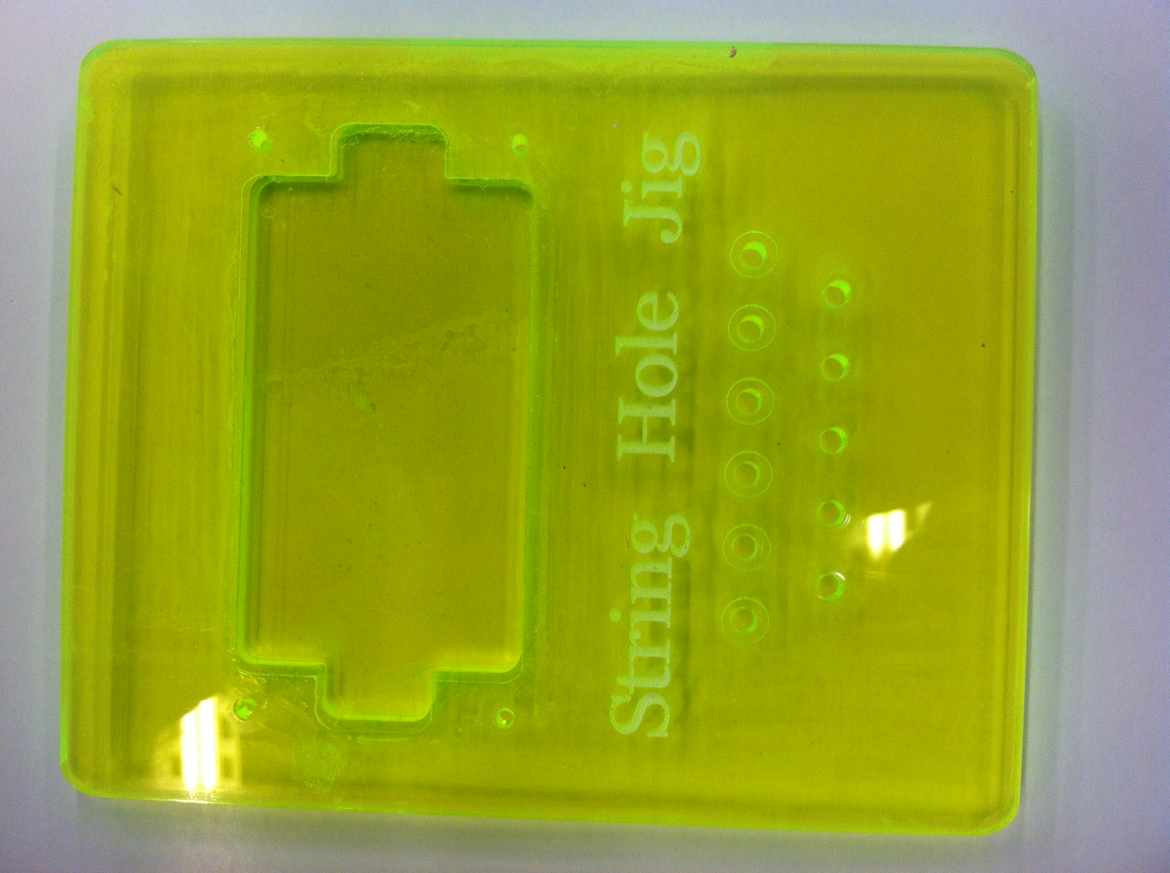

1. Students will create a CAD file and a manufacturing plan including machine applications to fabricate a plywood prototype template that allows for one to quickly and accurately locate the bridge string holes, mount screw holes and pickup ring screw holes. After testing and refinement of the plywood jig, expensive plexi-glass stock may possibly be used.

1. Students will develop a laser cut file with calculated speed and power requirements for Cutting and Engraving the needed features.
2. Students will need to engrave text onto the jig that will convey the drill size diameter and depth for the various holes.

**Activity**

Using CAD/CAM to design and manufacture the “String hole drilling jig”, we will use the size and location dimensions for quality/inspection of the finished part. The CAM process will use the lines and circles/arcs for the development of the machine codes to drive the CNC Machine (Laser Cutter/Engraver) to the correct position. These positions will be based on a **Part-Zero** or part **Origin** location determined by the dimensions placed by the designer. In this case the laser should be set to identify the Origin as the lower right corner plexi-glass stock.

CAD files inserted into CAM systems will typically use the basic part geometry for the development of the process and G code files. The dimensions and notes will be hidden or removed. This requires the CAD designer to be carful when creating the geometry and to focus on accurate geometry independent of the dimensions and notes. This is a new expectation of drafters since on a hand drawn piece the dimensions listed are the most important aspects of the drawing.

Using the above example lets review the hole features for the bridge and pickup ring jig.

The over all width of the jig should be **.500 greater than** the largest feature span in both the X and Y directions. This can be calculated by adding the dimensions that make up the part. This can be done in **Rhino 3D** by either using the **Bounding Box** command; followed by the **Offset** command. The outside edges of the jig need to be rounded with a fillet no less than .25”. The jig must be a precision fit that doesn’t allow for any movement.

Like the CAD system the CAM system uses Cartesian coordinates and the **left to right direction of these is the X axis** and the **top to bottom is the Y axis**. For the Laser Cutter/Engraver, this would then place the location of the **Origin** of the part at the lower right corner.

STOCK

After you have successfully created that CAD drawing for the drilling jig, you will be given a piece of .125” to .25” thick piece of plywood that is a slightly greater than the .500” Offset Bounding Box. From this stock you will create your Prototype drilling jig. You will need to test and refine your jig so that it accurate and simple to use.

After the Stock is setup geometry must be identified and if missing it should be created using the geometry tools located in the CAM system. Typically these tools will not be as robust as the tools found in the CAD system but they will provide the designer with options for building out the model or editing features without the need to return to the CAD system.

When the Geometry is completed the designer changes hats so to speak and puts on his/her Manufacturing hat. Deciding what operations are to be performed on which features. Where the tools should go, and what tools are required for the expected outcomes.

**Materials Required**

1. Safety instruction of machine tool operation and setup.

2. CAD/CAM software (Rhino 3D, Autocad, Inventor, Solidworks, LaserCut 5.3,) sketch pad and pencil.

3. Measuring tools, such as rulers, decimal equivalents charts, dial calipers, micrometers, calculators.

4. Electric guitar or parts for the data and design and application intent of neck plate.

5. Jig plate material.

**References**

* http://www.coolmath.com/decibels1.htm. Accessed April 2010.
* <http://wwnew.industrialpress.com/products/category_feature/MH> - Machinery’s Handbook
* <http://www.engineeringtoolbox.com/machinability-metals-d_1450.html> - Machinability of metals
* <http://en.wikipedia.org/wiki/Computer-aided_manufacturing>
* <http://en.wikipedia.org/wiki/Computer-aided_design>
* <https://grahamwideman.wikispaces.com/LaserCut+--+Software+overview>

**Standards**

Standards:

[CCSS.Math.Content.HSF-IF.C.7e](http://www.corestandards.org/Math/Content/HSF/IF/C/7/e) Graph exponential and logarithmic functions, showing intercepts and end behavior, and trigonometric functions, showing period, midline, and amplitude.

[CCSS.Math.Content.HSF-LE.A.2](http://www.corestandards.org/Math/Content/HSF/LE/A/2) Construct linear and exponential functions, including arithmetic and geometric sequences, given a graph, a description of a relationship, or two input-output pairs (include reading these from a table).