PH Testing Analysis for Swirl Painting

**Description of Activity**

* Students will record data when testing the PH values for swirl painting.
* This activity will allow students to realize the differences in PH value and how it effects the painting process.
* Science, Art, Engineering
* Grades: 9-12

**Learning Objectives:**

**(List measureable objectives)**

1. Students will record data every 30 minutes of water PH Value.
2. Students will measure water and borax for experiment.
3. Students will examine the differences in swirl painting with the PH values.
4. Students will record all data on the lab sheet and make conclusions of the PH level effects on the swirl dipping technique.

**Standards:**

CTE Standards

1. [Use English and metric measuring devices and systems.](http://www.cteresource.org/verso/courses/8436/engineering-drawing-and-design-tasklist/740588931)

**Materials Required:**

* Lab Sheet
* Paint for swirl dipping
* Borax
* Waste Container of Water
* Sample wood pieces
* Newspaper
* Measurement Tools

**Safety:**

**safetys:**

* Use gloves and safety glasses

**References:**

* Swirl Painting Document: Guitarbuilding.org

**Activity:**

* Students will use Lab Sheet to record data when testing PH levels of water for swirl painting, The students will also record the times, and effect of the PH value on the swirl painting process.

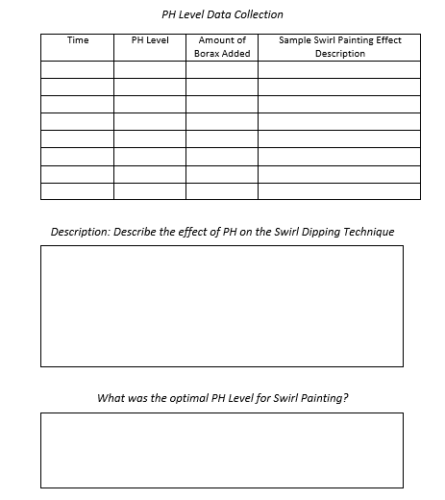

**Quiz:**

True or False Quiz

|  |  |
| --- | --- |
| **Take Data** During **Lab** | True |
| Don't [Play Mad Scientist](http://chemistry.about.com/od/madscientistlab/ig/Mad-Scientist-Pictures/Mad-Scientist.htm) | True |
| Don't [Eat or Drink in Lab](http://chemistry.about.com/od/healthsafety/ig/Laboratory-Safety-Signs/Do-Not-Eat-or-Drink-Sign.htm) | True |
| **Casually Dispose of Chemicals Down the Drain** | False |
| **Don't Taste or Sniff Chemicals** | True |
| **Identify the Safety Equipment** | True |
| Dress Appropriately ([for chemistry lab](http://chemistry.about.com/od/chemistrylabexperiments/a/Chemistry-Lab-Safety-Contract.htm), not fashion or the weather) | True |
| **Read the Chemical Safety Information**  **Example:**  [Material Safety Data Sheet](http://chemistry.about.com/od/materialsafetydatasheets/index.htm) (MSDS) | True |
| **Follow the instructions given by your instructor or lab manual.** | True |

**Reviewing Faculty Cohort Members:**

* "Bruce.Toney@marion.k12.fl.us" <Bruce.Toney@marion.k12.fl.us>,

David DeLade <dmdelade@wsfcs.k12.nc.us>,