Wood for Guitars

In this activity, participants will measure the stiffness per unit weight of wood samples.

Learning Objectives:

- Students will accurately determine the dimensions of their wood samples
- Students will measured deflections of their cantilevered samples
- Students will produce a graph of deflection vs force for each of their samples and calculate the slope of the curve to calculate the elastic modulus.
- Students will calculate the elastic modulus of their samples
- Students will calculate the stiffness/weight ratio of their samples

Materials Required:

- Wood samples approximately 380mm x 20mm x 6mm. My samples includes oak, cedar, cherry, walnut and maple.
- A Vernier caliper
- A ruler or printed scale
- A laboratory scale capable of measuring 200gm
- A weight of approximately 6-100gm laboratory masses
- One clamps (Quick Grips or C‐clamps work well)
- A pencil
- A bench with a squared edge
- A Vernier LabQuest
- One Vernier Motion detector

Safety:
Be sure to keep feet from beneath the weight in case the wood sample breaks

References:

  - Mott, R (2007) Applied Strength of Materials, 5th ed. Prentice Hall.
  - Bergman, et al, Forest Products Lab (2010) Wood Handbook, Wood as an Engineering Material, FPL‐GTR‐190, www.fpl.fs.fed.us/products/publications.

Standards:

Procedure
The object is to calculate the material stiffness of several species of wood and to compare the stiffness to weigh ratios. The stiffness of structure (like a small wood beam) is determined by its geometry and the material stiffness. All the beams should be the same length and cross-sectional shape, so any differences in stiffness are due to the material properties. The material stiffness is called the modulus of elasticity. The stiffness due to the cross-sectional shape of the beam is called the area moment of inertia.

The procedure is:

  - Using the caliper, determine the width and thickness of two specimens. It is a good idea to write dimensions right on the specimens. If you want to speed the activity, you can provide the specimens with the dimensions already written on them.

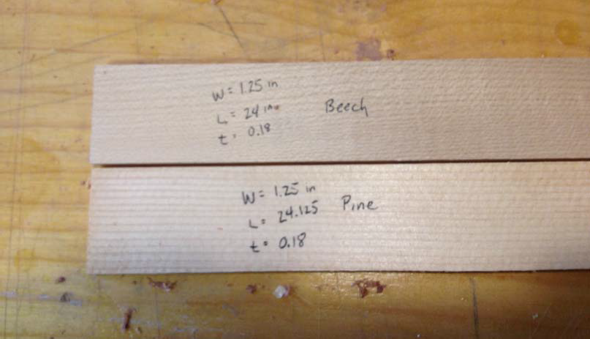

Units: To be consistent with international standards, it makes sense to do all measurements and calculations in metric units. All forces should be in Newtons, all masses should be in kilograms and all lengths should be in meters.

  - Use a laboratory scale to weigh each of your specimens. You’ll need to keep track of the specimens, so you should number or label them. Record the weights in kilograms (which is actually mass, not weight).
  - You’ll need to know the density of each of the wood specimens. Calculate the volume in m3 for each specimen. Divide the mass by the volume to get mass density. Record the density for each specimen.

  - The most complicated measurement is recording displacement due to a load. Clamp the specimen onto the table with a C clamp so 25 mm of the wood specimen is on the table with the rest of the sample suspended over the edge of the table. Place the Vernier Motion detector on the floor or on a chair directly below the very outside end of the wood specimen. Make sure the motion detector is picking up the end of the wood specimen. Push the specimen up and down while watching the reading on the LabQuest to see if the reading changes as the specimen if bent. Be sure that the edge of the table is a 90 degree corner to form a good boundary condition. Don’t use a table edge that has been rounded.

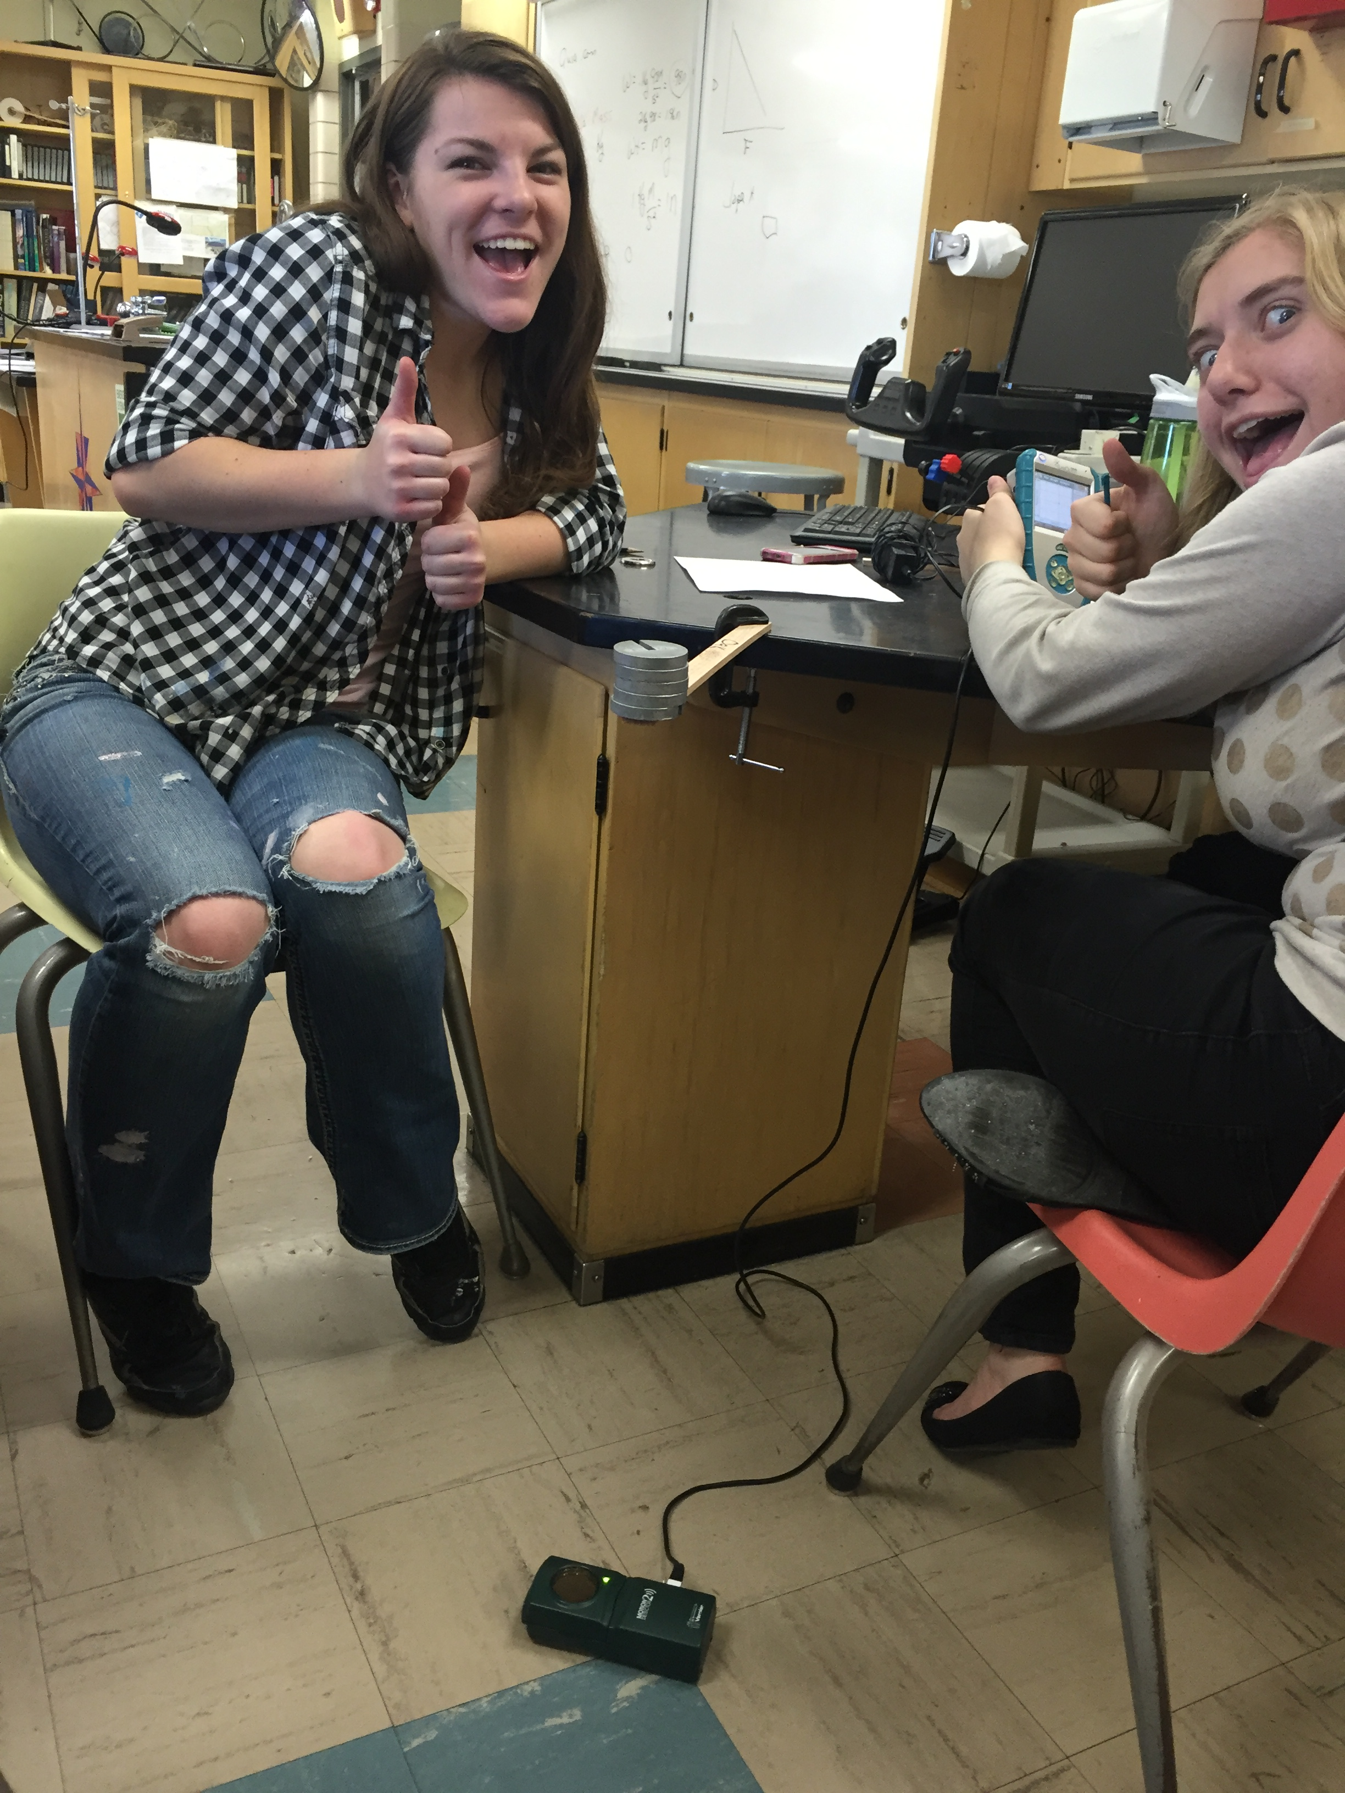

  - Next click the Mode button on the LabQuest and choose events with entry. For the
name type in Force and the units are (n) for Newton’s. Next click the start button and the keep button will show on the screen. With no weight on the beam click on the keep button and enter 0 for the force. Now put a 100 gram mass on the end of the beam so that the end of the beam and the end of the mass are aligned. Click keep and enter .98 for the number of newtons of the weight. Continue adding masses in 100 gram increments until you reach 500g or 4.9 n. At that time you can stop recording by pushing the stop button. A graph should appear that will show a negative linear relationship. The negative direction can be ignored and it shows negative simply because the weight pushes the end of the beam towards the motion detector rather than away from it. Hit the analyze button at the top of the LabQuest then Curve Fit, click the position graph and then choose linear fit. Record the slope on your data sheet as a positive value.

  - Multiply the mass by the acceleration of gravity to get weight in Newton’s.

Aside: Wood displays a property known as creep. That means that it continues to deform slowly after a load is applied. The beams used in this experiment may creep when loaded, so you may notice that your test beam continues to move just a little. Rather than try to wait until it stops creeping, record the deformation right after applying the load.

  - Once you have the displacements, you can calculate the modulus of elasticity for each beam. To do that, you’ll need to use the equation for the displacement of a cantilevered beam:

You’ll need some definitions:

∆y =
FL3 3EI

F = Force applied – weight in this case. Force is in Newton’s
L = Length of beam starting from the edge of the table, L is in meters
I = Area moment of inertia of the cross-section of the beam. This number describes the stiffness of the beam due to its cross-sectional shape

$$I=\frac{1}{12}bh^{3}$$

Where b is the width of the beam and h is the thickness of the beam. Both dimensions should be in meters. The units for I are m⁴.

E = Elastic modulus. This is stiffness due to the material

The displacement equation can be re-arranged
L^3
E =
3I(slope)

We can measure or calculate everything on the right hand side of the equation. Note that elastic modulus is likely to be a very big number. For example, the elastic modulus of hard maple (often used for necks) is listed as approximately 12 ×109 Pa or 12 GPa.

  - The last step is to calculate the ratio of stiffness to weight. For each specimen, divide the elastic modulus in GPa by the density. Record the resulting values and put them in order from the highest to the lowest.

The woods most favored for acoustic guitars are often the ones with the highest stiffness to weight ratio. In particular, Sitka spruce is favored for the soundboards of acoustic guitars. Electric guitars can be made with a wider range of woods. It is typical to use hard maple or mahogany for the neck and something less dense for the body. Alder and Basswood are typical choices for body wood, though soft maple is sometimes used.

Wood | Length (m) | Thickness (m) | Width (m) | Mass  (Kg.) | Density  (Kg/m^3) | Slope of graph (m/n) | I- area moment of inertia (m^4) | E elastic modulus (Pa)=n/m^2 | Stiffness/weight  Elastic modulus divided by density
Cherry
Walnut
Oak
Cedar
Maple

Which wood has the greatest stiffness/density?

